Project Design Phase-II Technology Stack (Architecture & Stack)

Date | 17 February 2026
Team ID | LTVIP2026TMIDS78241
Project Name: | LearnHub — Online Learning Platform (OLP)
Maximum Marks | 4 Marks

Technical Architecture:
The Deliverable shall include the architectural diagram as below and the information as per the table1 & table 2
LearnHub OLP — MERN Stack Technical Architecture Diagram
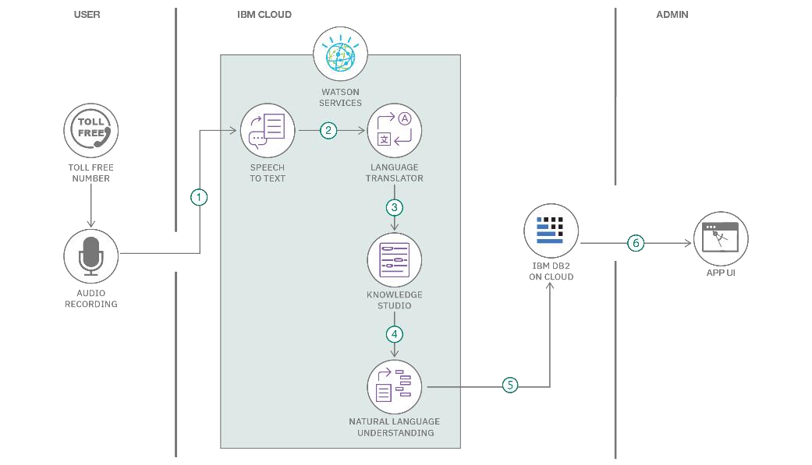
Reference: https://developer.ibm.com/patterns/ai-powered-backend-system-for-order-processing-during-pandemics/
Guidelines:
Include all the processes (As an application logic / Technology Block)
Provide infrastructural demarcation (Local / Cloud) Indicate external interfaces (third party API’s etc.) Indicate Data Storage components / services Indicate interface to machine learning models (if
applicable)

Table-1 : Components & Technologies:

S.No | Component | Description | Technology
1. | User Interface | React.js SPA served to learners, instructors & admins via browser.  Responsive on desktop and mobile (Bootstrap + MUI). | React.js + Bootstrap 5 + Material UI (MUI)
2. | Application Logic-1 | Course management, user auth, enrollment & payment logic | Node.js + Express.js (REST API)
3. | Application Logic-2 | Video/image processing via Cloudinary SDK | Cloudinary SDK (video/image CDN processing)
4. | Application Logic-3 | Email notifications for registration, enrollment & certificates | Nodemailer + Gmail SMTP (email notifications)
5. | Database | Stores users, courses, modules, enrollments & certificates | MongoDB (NoSQL) via Mongoose ODM
6. | Cloud Database | MongoDB Atlas cloud cluster with auto-backups. | MongoDB Atlas (Cloud Cluster with Replica Sets)
7. | File Storage | Course videos & thumbnails via Cloudinary CDN | Cloudinary (media CDN) + Local FS (dev environment)
8. | External API-1 | Secure payment processing for paid course purchases. | Stripe Payment API
9. | External API-2 | Purpose of External API used in the application | Google OAuth 2.0 (Social Login)
10. | Machine Learning Model | Recommend courses based on learner history (future scope). | Course Recommendation Engine (Collaborative Filtering — Future  Scope)
11. | Infrastructure (Server / Cloud) | Application Deployment on Local System / Cloud Local Server Configuration:  Cloud Server Configuration : | Vercel (Frontend) + Render (Backend)  + Nginx (Reverse Proxy)

Table-2: Application Characteristics:

S.No | Characteristics | Description | Technology
1. | Open-Source Frameworks | React.js, Express.js, Mongoose, Node.js, Bootstrap 5 (all MIT) | React.js (MIT), Express.js (MIT), Mongoose (MIT), Node.js (MIT)
2. | Security Implementations | JWT, bcrypt, HTTPS, CORS, Helmet.js, Stripe PCI-DSS compliance, input validation | JWT auth, bcrypt hashing, HTTPS, CORS, Helmet.js, Stripe PCI compliance
3. | Scalable Architecture | 3-tier MERN. Stateless REST API allows horizontal Express node scaling. | Cloudinary CDN, MongoDB indexing, gzip compression, lazy loading.
4. | Availability | Render auto-scaling + Nginx reverse proxy + MongoDB Atlas replica sets (99.5% uptime). | Technology used
5. | Performance | Cloudinary CDN + MongoDB indexing + gzip compression + lazy loading. Target: <500ms API  response. | Technology used

References:
https://c4model.com/
https://developer.ibm.com/patterns/online-order-processing-system-during-pandemic/ https://www.ibm.com/cloud/architecture
https://aws.amazon.com/architecture
https://medium.com/the-internal-startup/how-to-draw-useful-technical-architecture-diagrams-2d20c9fda90d

